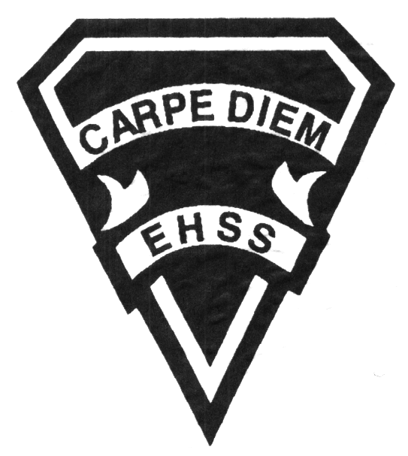

##### Grade 10

##### Film Arts Majors

# **TGJ 2OP**

**Evaluation Profile & Outline**

**FILM TECHNOLOGY**

## Earl Haig

Secondary

School

**Course Description/Rationale/Overview:** This course hones the students’ technical abilities learned in the course TGJ 1OP. Students will apply critical and creative processes to produce work in various applied techniques and mass media applications. Emphasis will be placed on ideas and the production of film. Students will research, plan, draw, record and edit their work. Students will focus on improving their technical abilities of producing film while challenging the viewers with authentic, thought provoking ideas. This course takes the theoretical learning and applications from ADV2OP and technically applies it to film.

**Evaluation, Mark Breakdown:**

Year’s Work: **70%**

Final Summative: **30%**

(During final six weeks of classes)

**LAB HOURS:** In addition to class time, the Communications Technology Lab will be open before and after school *upon student request*. Students missing any classes may also be asked to make up work at that time. **EQUIPMENT:** Students must get the parental permission form signed before borrowing any equipment. In this, they agree to be responsible for any loss or damage. ***All equipment must be returned by 8:30 am the next morning. Failure to return the equipment on time will result in loss of borrowing privileges.***

**LEARNING SKILLS: Responsibility** – meets deadlines; takes responsibility for own behaviour**. Organization** – establishes priorities and manages time; uses information, technology and resources top complete tasks time management**. Independent Work** – follows instruction with minimal supervision; uses class time appropriately to complete tasks**. Collaboration** – accepts an equitable share of work in a group; builds healthy peer relationships; works with others to achieve group goals. **Initiative** – looks for opportunities for learning; demonstrates curiosity; approaches new tasks with a positive attitude**. Self-regulation** – sets own goals, monitors own progress; seeks assistance when needed; makes an effort with responding to challenges

**Achievement Categories and Weighting**

* **Knowledge / Understanding 20%**: knowledge of facts and terms; understanding of concepts, principles, guidelines and strategies; understanding of relationships among concepts.
* **Application 35%**: applied knowledge in completion of video and all other accompanying project elements that fulfills the project requirements
* **Thinking Inquiry 25%:** Formulating questions; planning, selecting strategies and resources; analyzing and interpreting information, and forming conclusions.
* **Communication 20%**:Communication of information and ideas, communication for different audiences, use of various forms of communication.

**Course Requirements and Department Policies:** Class Work – Students must come to class prepared to work on individual or group projects for the whole class. At times, students are expected to do extra work and perform duties related to the program outside of class time. That said, students must complete a minimum of 75% of the project in class to allow for teacher and class input.Tests & Assignments – It is the student’s responsibility to make arrangements for missed tests/projects and/or any class evaluated work. Students must have a valid reason for missed evaluations and produce an explanatory note that explains the reason why such an evaluation has been missed (example, a doctor’s note). Failure to communicate with teacher in advance and/or to not produce an explanatory note may result in a zero in the evaluation. **Also**, **students must adhere to the strict due dates of projects/assignments**. **Not adhering to the due dates not only compromises the student’s (and class’) final products but may have an effect on the student’s overall evaluation.** Studio Hours – In addition to class time, the Film Arts Studio will open after school *on request* for about 30 minutes. If longer times are needed they can be negotiated with a Film Arts teacher. Missed classes must be made up after school or during daytime open studio time.

**Class Requirements:** Each Student is required to have a dedicated notebook for this class. On-line resources are provided along with handouts and exemplars. Each student should have an external hard drive (500GB or more) used to back-up all class projects. Students may use their own equipment if they wish.

**Assessment and Evaluation Strategies:** Rubrics provided at the beginning of each unit outlining the expectations and time lines for the unit.

**Assessment:** Homework checks, peer assessment, presentations, reflection writing, teacher observation.

**Evaluation:** Tests, in class assignments/projects completed on time & according to the rubric provided.

**UNITS OF STUDY:** *All major unit projects will require pre-production, production and post-production. Students will be expected to produce story treatments, storyboards and detailed shot lists for every project. All lessons are taught through an integration of the units of study. Lessons will fluctuate between each unit to better address filmmaking techniques and application in a more holistic manner. This course is taught conjointly with ADV2OP.*

**UNIT 1: SETTING THE MOOD**

* Opening Title Sequence
  + Feel, mood and pace
  + Creating imagery for the film – picture/sound/graphics
  + Graphic Design – Typography, Colour
* Editing-After Effects
  + Animations
  + Masks and Shapes
  + Type/Logos
  + Working with stills and video
  + Challenges

**UNIT 2: CONTINUITY AND IN CAMERA TECHNIQUES**

* Lenses and Focal Points
* Choosing the right lens for appropriate story application
* Exposure
* Slow motion
* Rack Focus
* Mastershot versus Triple-Take Technique

**UNIT 3: THE MEANING OF CAMERA SHOTS**

* Why use a particular shot?
* Show it with shots.
* Using the CU and MCU effectively

**UNIT 4: USING COMPOSITION TO BRING OUT “STORY MEANING”**

* Compositional Rules and Language
* Creating picture harmony
* Technical elements of Story
* Principles of Story/Picture Design

**UNIT 5: Final Culminating Project** (30% of Final Grade)

**ACTIVITIES, HOMEWORK, ASSIGNMENTS, TESTS/QUIZZES AND PROJECTS**

Each unit will present various challenges. In class activities are designed to grasp the content learned in class. Usually there will be 1 or 2 evaluated activity per unit plus one major project. Your utmost attention and participation is required.

**PLAGIARISM**

Students are expected to submit only their own original work activities, assignments and projects done in or out of class. Plagiarism—falsely representing other’s work as your own—and academic dishonesty will be dealt with on a case-by-case basis, but will be investigated, and a mark of zero will be assigned for plagiarized work (see Student Agenda).