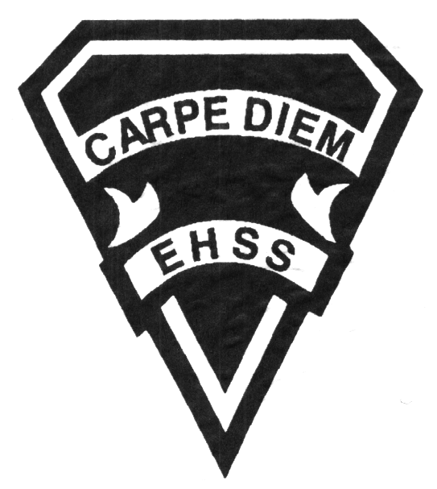

**Course Description:**

This course emphasizes the skills and information students need to acquire and demonstrate in order to lead a healthy active life well beyond high school. Students address their current personal activity agenda and forecast how they may change in the future. After analysing the benefits of life-long participation they describe and apply strategies that promote active participation. Students will create a personal health-related fitness program, with an emphasis on safety guidelines (equipment, facilities, supervision) in school and the community. Some units may also include pilates, yoga, stability ball workouts and step aerobics.

Earl Haig

SecondarySchool

**PAF3OM**

**Grade Eleven Fitness**

**Personal Fitness**

**PAF3OM**

**Evaluation Profile & Outline**

**Class Requirements:**

* Earl Haig Phys-Ed Uniform ($25)
* Phys. Ed. Binder
* Proper Footwear
* Positive Attitude

**Assessment and Evaluation Strategies**

**Assessment:**

Daily participation, peer assessment, presentations, reflection writing, role-play scenarios, observation, discussion, open questions and parallel tasks

**Evaluation:**

Tests, oral presentations, research assignments, technical evaluations, labs, journals and logs

**Late and/or Missed Evaluation**

Our policy on late assignments and missed tests is in complete agreement with the school-wide policy. Students should consult their agenda, read these policies, and ask for clarification if necessary.

**Learning Skills**

**Responsibility** – meets deadlines; takes responsibility for own behaviour

**Organization** – establishes priorities and manages time; uses information, technology and resources top complete tasks time management

**Independent Work** – follows instruction with minimal supervision; uses class time appropriately to complete tasks

**Collaboration** – accepts an equitable share of work in a group; builds healthy peer relationships; works with others to achieve group goals

**Initiative** – looks for opportunities for learning; demonstrates curiosity; approaches new tasks with a positive attitude

**Self-regulation** – sets own goals and monitors own progress; seeks assistance with needed; makes an effort with responding to challenges

**Evaluation**

TERM MARK BREAKDOWN

* **Application 60%**: Active participation, personal physical fitness, safety, behaviour, strategies and tactics, leadership, and living skills
* **Knowledge / Understanding 20%**: knowledge of facts and terms; understanding of concepts, principles, guidelines and strategies; understanding of relationships among concepts.
* **Communication 10%**:Communication of information and ideas, communication for different audiences, use of various forms of communication.
* **Thinking Inquiry 10%:** Formulating questions; planning, selecting strategies and resources; analyzing and interpreting information, and forming conclusions.

**Achievement Categories and Weighting**

Knowledge/Understanding 20%

Application 60%

Thinking/Inquiry 10%

Communication 10%

###### Final Mark

Year’s Work: 70%

Final Summative Evaluation 30%

* Skill Testing
* Fitness Portfolio
* Written Test
* Participation Event

**Curriculum Strands**

Physical Activity

Healthy Living

Living Skills

Active Living

## Earl Haig

SecondarySchool



**PAF3OM**

**Grade Eleven Fitness**

**Personal Fitness**

Course Outline:

**Healthy Living**

Students will investigate the impact of health issues on themselves and others while studying sexual and reproductive health, relationship violence, personal safety, and mental health. Students will demonstrate an understanding of the strategies and skills required in making good decisions, setting goals, and managing stress. The connection between positive mental health and healthy relationships are examined and related to a healthy lifestyle. The student can expect a minimum of one of the following evaluations in each health unit: formal test, quiz, oral presentation, media product, research assignment, IDEAL, role play scenarios, case study.

**Physical Fitness**

Students will develop an understanding of the components of health-related fitness (cardiorespiratory, muscle strength and endurance, flexibility) and the potential benefits that can be achieved. They will assess their fitness levels and design a personal program intended to address self identified goals. Through engagement in a variety of fitness activities, students will demonstrate improvements in their personal fitness level. The students will learn how to plan, design and execute a program at the beginning of the year and establish personal goals using the SMART model. The students are to work on these goals throughout the year both in HPE class and at home. The students will then revisit their program and SMART goals as part of their summative evaluation along with a reflective piece.

**Active Living**

The fitness program includes a variety of activity units where the students will participate vigorously and learn proper strategies and techniques in fitness training. The units are a balanced selection of activities from areas such as speed, endurance, flexibility, strength and balance training. The students will develop an awareness of what motivates them to be active. The students are expected to learn a basic anatomy of the body and use this understanding to create and improve their own training. Finally, a key component of fitness is daily participation. Please visit the school website and click on the HPE department to see a **Participation Rubric** which identifies key components of participation.

**Living Skills**

The students will interact in supportive, safe, enjoyable and challenging settings to experience responsible behaviour, initiative, effort, fair play active listening skills, effective group work, personal safety, and conflict resolution. Opportunities to develop decision-making, goal setting and assertion skills will be provided throughout the year.

Earl Haig Secondary School

**PAF3OM**

**Evaluation Profile & Outline**