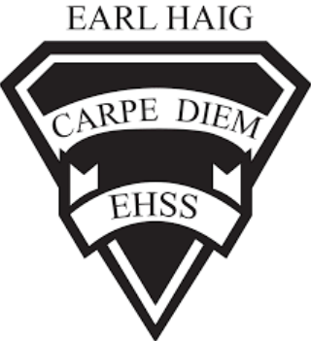 | Course Outline and Evaluation Summary  Course Code: HFC3M  Title of Course: Food & Culture  Department: Social Science | 2022-2023  416-395-3210  x20075

Course Description
In this course, students will focus on the flavours, aromas, cooking techniques, foods, and cultural traditions of world cuisines. Students will explore the origins of and developments in diverse food traditions. They will demonstrate the ability to cook with ingredients and equipment from a variety of cultures, compare food-related etiquette in many countries and cultures, and explain how Canadian food choices and traditions have been influenced by other cultures. Students will develop practical skills and apply social science research methods while investigating foods and food practices from a around the world. Prerequisite: None

Course Evaluation
Course evaluations incorporate one or more of the achievement categories (KICA). A brief description of each category can be found here. The final grade is calculated using the weighted percentages below.
Term Work: | A variety of tasks where you show your learning and have marks assigned using the Achievement Categories/Strands |  | Summative  Evaluation: | Marked summative tasks which assess your learning on the entire course
70% | 25% | Knowledge & Understanding | 30% | 30% | Culminating Task & Presentation
 | 25% | Thinking & Inquiry
 | 25% | Application
 | 25% | Communication

Learning Skills
Learning skills provide Information to help students understand what skills, habits & behaviors are needed to work on to be successful. These are not connected with any numerical mark. A brief description of each skill can be found here.
Responsibility, Organization, Independent Work, Collaboration, Initiative and Self-Regulation
E – Excellent G – Good S – Satisfactory N – Needs Improvement

Required Materials
Any educational resource required for this course will be provided by the school. It is the student’s responsibility to come to class with these materials.

School/Departmental/Classroom Expectations
Attendance: The student is expected to attend class on time. Parents/guardians will be contacted if lates/attendance becomes an issue/hindrance. If the student knows about an absence in advance, they should contact the teacher.
Plagiarism/Cheating: A mark of 0 will be assigned for any work submitted that does not belong to the student. A mark of 0 will be assigned to a student who was found to have cheated. Parents/guardians will be informed.
Missed Work: If a student is absent from class, (e.g. illness, sports team) it is their responsibility to find out what they have missed and to catch up. The student is responsible for completing all of the work that was missed due to an absence. If a student misses an assignment or test without a legitimate explanation and documentation, marks up to and including the full value of the evaluation may be deducted. Make-up tests must be arranged to be written.
Late Work: Late work may result in a deduction of marks up to and including the full value of the evaluation.
\\\\

Course Assessment Tasks
Unit/Topic/Strand | Big Ideas | Major Assignments / Evaluations | Estimated Duration
Unit 1: | Food and culture Identity  cooking equipment, dietary guidelines around the world, what the world eats, nutrition and food labels, elements of a recipe, kitchen safety test. | -test  -written assignment  -visual and / or oral presentations | -approximately 25 hrs.
Unit 2: | Food & culture Influences  Personal connections to food, social science survey, food trends, what influences food choices, food memories | -written assignment  -visual and / or oral presentations | -approximately 25 hrs.
Unit 3: | Canadian Food & Culture  Indigenous food & culture. Canadian food sources, uniquely Canadian foods, food insecurity, budgeting and financial literacy | -written assignment  -visual and / or oral presentations | -approximately 25 hrs.
Unit 4: | Global Food & Culture  culinary tourism, cookbooks and menus, international herbs and spices, cultural foods, traditions and etiquette | -written assignment  -visual and / or oral presentations | -approximately 25 hrs.
Culminating Task(s) | Final Project |  | 10 hrs

