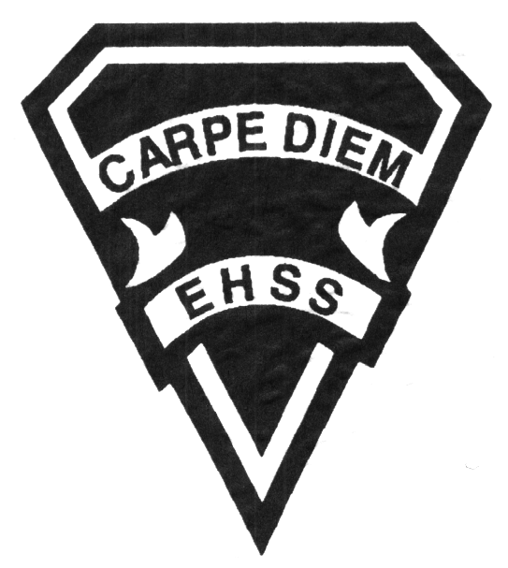

### GLS4O1

##### Advanced Learning Strategies

**Student Success**

## Earl Haig

SecondarySchool

# **Course Code**

**Evaluation Profile & Outline**

**Course Description/Rationale/Overview:**

This course improves students’ learning and personal-management skills, preparing them to make successful transitions to work, training and / or postsecondary education destinations. Students will assess their learning abilities and use literacy, numeracy, and research skills and personal-management techniques to maximize their learning. Students will investigate trends and resources to support their postsecondary employment, training and /or education choices and develop a plan to help them meet their learning and career goals.

**Assessment and Evaluation Strategies**

**Assessment: (AS & FOR Learning)**

*Formative peer & self assessments, teacher conferences*, *diagnostic checks, observation, descriptive feedback, graphic organizers, exit cards, differentiated instruction of content, process & product etc.*

**Evaluation: (OF Learning)**

*Summative portfolios, goal setting, learning inventories, reflective journals, reading responses, writing / media tasks, work logs, self-evaluations etc.*

**Class Requirements:**

-Agendas are used & reviewed daily

-Personal reading material is required for DEAR time

-Course binders are kept in the classroom and maintained daily with a log sheet

**-**Textbook: Think Smart (Not individually issued)

**Late and/or Missed Evaluation**

Our policy on late assignments and missed tests is in compliance with the school-wide policy located in the agenda and conforms with the ministry document: *Growing Success*

**Subject-Specific/Department Information**

**Contact Info: x20269**

-GLS classroom 265 is open during lunch for additional support

-GLS students are encouraged to seek extra help when needed

**Learning Skills\***

**Responsibility** – meets deadlines; takes responsibility for own behaviour

**Organization** – establishes priorities and manages time; uses information, technology and resources top complete tasks time management

**Independent Work** – follows instruction with minimal supervision; uses class time appropriately to complete tasks

**Collaboration** – accepts an equitable share of work in a group; builds healthy peer relationships; works with others to achieve group goals

**Initiative** – looks for opportunities for learning; demonstrates curiosity; approaches new tasks with a positive attitude

**Self-regulation** – sets own goals and monitors own progress; seeks assistance with needed; makes an effort with responding to challenges

###### Final Mark

**Course Work 70%**

**All work is project and assignment based with a focus on literacy, numeracy and personal management skills**

**Final Summative Evaluation 30%**

**Culminating Project / Portfolio**

**Achievement Categories and Weighting**

* **Knowledge / Understanding 25 %**: knowledge of facts and terms; understanding of concepts, principles, guidelines and strategies; understanding of relationships among concepts.
* **Application 25%**: Demonstration of knowledge and understanding as applied in specific assignments.
* **Thinking 25 %:** Formulating questions; planning, selecting strategies and resources; analyzing and interpreting information, and forming conclusions.
* **Communication 25 %**:Communication of information and ideas, communication for different audiences, use of various forms of communication.



## Earl Haig

SecondarySchool

### GLS4O1

##### Advanced Learning Strategies

**Student Success**

# **Course Code**

**Evaluation Profile & Outline**

**Course Outline/Curriculum Strands:**

**Learning Skills**

-Evaluate learning skills and Thinking Strategies

-Apply Literacy and Numeracy Skills and Strategies

-Analyze personal learning skills and styles

**Personal management**

-Identify and Applying Personal-Management Skills

-Explain the Impact of Personal Factors on achievement

-Apply Interpersonal Skills and strategies

**Exploration of Opportunities**

-Demonstrate knowledge of workplace trends

-Apply research and career-exploration strategies to identify post-secondary options

-identify and describe learning environments and resources available to all lifelong learners

**Preparation for Transitions and Change**

-Evaluate personal transition skills and strategies

-Demonstrate kills and strategies needed for the work search process

-Demonstrate effective use of decision-making, goal setting, action planning skills and strategies to prepare for a postsecondary transition.