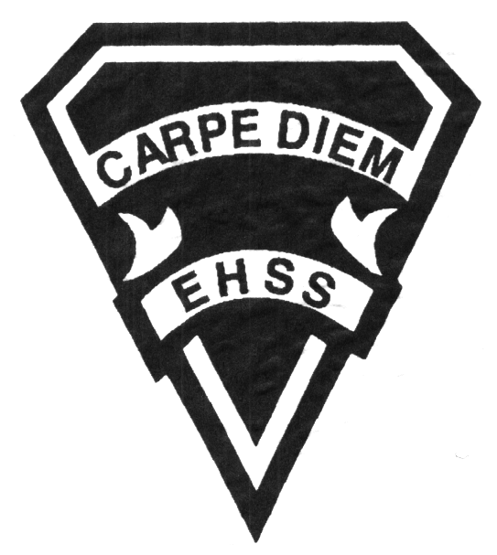

## Earl Haig

Secondary School

### GLE 4O9

##### Learning Strategies

**Special Education**

# **GLE 4O9**

**Evaluation Profile & Outline**

**Course Description/Rationale/Overview:** This senior credit course assists students who have an Individual Education Plan (IEP) to make successful transitions to post secondary education or the world of work. Students will learn how to assess their learning abilities and use critical reading, time management, and other techniques for promoting effective life long learning. In addition, they will investigate the requirements necessary for employment and post secondary education or training and develop plans that will enable them to pursue these paths after secondary school.

**Assessment and Evaluation Strategies**

*Assignments, Independent Work, Journals, Self-Evaluation, Student/Teacher Conferences, Notebook/Agenda Checks, Overall Performance, Attitude and Participation*

**Assessment:**

*Observation, Self-reflection, Overall performance*

**Evaluation:**

*Journals, Class assignments, Independent work*

**Class Requirements:**

Course work is provided by the teacher.

Students are responsible for providing their own school agenda, paper, pens, pencils, calculator and any additional schoolwork with which they require assistance.

**Late and/or Missed Evaluation**

Our policy on late assignments and missed tests is in complete agreement with the school-wide policy.

**Subject-Specific/Department Information**

Resource Room 261

Resource Office 263

Phone number: (416)395-3210 ext. 20142

Please leave a brief message and your call will be returned as soon as possible.

**Learning Skills**

**Responsibility** – meets deadlines; takes responsibility for own learning

**Organization** – establishes priorities and manages time; uses information, technology and resources to complete tasks: overall time management

**Independent Work** – follows instructions with minimal supervision; uses class time appropriately to complete tasks

**Collaboration** – accepts an equitable share of work in a group; builds healthy peer relationships; works with others to achieve group goals

**Initiative** – looks for opportunities for learning; demonstrates curiosity; approaches new tasks with a positive attitude

**Self-regulation** – sets own goals and monitors own progress; seeks assistance when needed; makes an effort to respond to challenges

###### Final Mark

**Year’s Work 70%**

*Course assignments*

*Journals*

*Independent work*

**Final Summative Evaluation 30%**

*In class reflections and assignments*

**Achievement Categories and Weighting**

* **Knowledge / Understanding 25 %**: knowledge of facts and terms; understanding of concepts, principles, guidelines and strategies; understanding of relationships among concepts
* **Application 25 %**: Applying personal learning styles and abilities to assignments and independent work
* **Thinking / Inquiry 25%:** Formulating questions; planning, selecting strategies and resources; analyzing and interpreting information and forming conclusions
* **Communication 25%**:Communication of information and ideas, communication for different audiences, use of various forms of communication



*From: Ontario Ministry of Education. *Growing Success: Assessment, Evaluation, and Reporting in Ontario Schools*. Toronto: Ministry of Education, 2010, 11.

## Earl Haig

Secondary School

**2019/2020**

### GLE 4O9

##### Learning Strategies

**Special Education**

# **GLE 4O9**

**Evaluation Profile & Outline**

**Course Outline/Curriculum Strands:**

**Strand 1: Managing Transitions to Post Secondary Institutions and/or The World of Work**

* Comprehension and understanding of cognitive processes
* Exploring options
* Taking responsibility for their own learning
* Self advocacy

**Strand 2: How Can I Maximize My Potential for Learning Now That I’m Leaving High**

**School?**

* Application of thinking and learning skills and strategies
* Utilization of research and inquiry skills
* Personal management and transitional skills
* Comprehension and application of career planning and implementation

**Strand 3: How Can I Plan Ahead and Put My Plan into Action?**

* Utilizing research and inquiry skills
* Identifying, evaluating and selecting options based on self analysis and research
* Developing and adjusting personal plans for ongoing changes and transitions

**Strand 4: Post Secondary Options: Workplace? College? University? Travel? Etc.**

* Self evaluation and realizing your potential
* Developing and adjusting personal plans for ongoing changes and transitions
* Understanding and using personal and transitional management skills