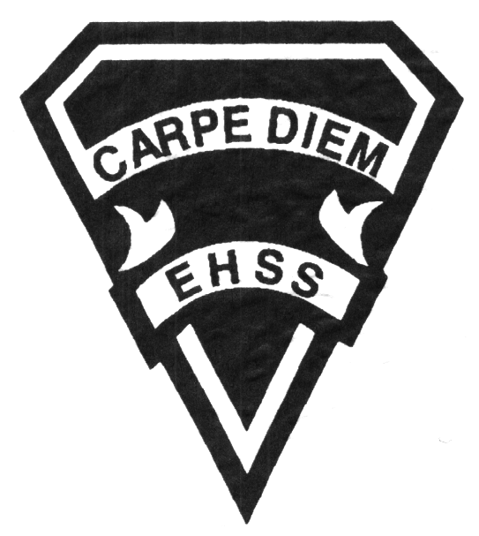

## Earl Haig

Secondary School

### GLE 2O9

##### Learning Strategies

**Special Education**

# **GLE 2O9**

**Evaluation Profile & Outline**

**Course Description/Rationale/Overview:** This credit course allows students who have an Individual Education Plan (IEP) to explore learning strategies and helps students become better, more independent learners while increasing their personal management skills, both in school and in other contexts. Students will learn how to develop and apply a range of strategies to improve their learning and achievement, particularly their literacy, numeracy, communication and planning skills. This course will increase students’ confidence, motivation and self advocacy skills.

**Assessment and Evaluation Strategies**

*Assignments, Independent Work, Journals, Self-Evaluation, Student/Teacher Conferences, Notebook/Agenda Checks, Overall Performance, Attitude and Participation*

**Assessment:**

*Observation , Self-reflection, Overall performance*

**Evaluation:**

*Journals, Class assignments, Independent work*

**Class Requirements:**

Course work is provided by the teacher.

Students are responsible for providing their own school agenda, paper, pens, pencils, calculator and any additional schoolwork with which they require assistance.

**Late and/or Missed Evaluation**

Our policy on late assignments and missed tests is in complete agreement with the school-wide policy.

**Subject-Specific/Department Information**

Resource Room 261

Resource Office 263

Phone number: (416)395-3210 ext. 20142

Please leave a brief message and your call will be returned as soon as possible.

**Learning Skills**

**Responsibility** – meets deadlines; takes responsibility for own learning

**Organization** – establishes priorities and manages time; uses information, technology and resources to complete tasks; overall time management

**Independent Work** – follows instructions with minimal supervision; uses class time appropriately to complete tasks

**Collaboration** – accepts an equitable share of work in a group; builds healthy peer relationships; works with others to achieve group goals

**Initiative** – looks for opportunities for learning; demonstrates curiosity; approaches new tasks with a positive attitude

**Self-regulation** – sets own goals and monitors own progress; seeks assistance when needed; makes an effort to respond to challenges

###### Final Mark

**Year’s Work 70%**

*Course assignments*

*Journals*

*Independent work*

**Final Summative Evaluation 30%**

*In class reflections and assignments*

**Achievement Categories and Weighting**

* **Knowledge / Understanding 25 %**: knowledge of facts and terms; understanding of concepts, principles, guidelines and strategies; understanding of relationships among concepts
* **Application 25 %**: Applying personal learning styles and abilities to assignments and independent work
* **Thinking / Inquiry 25%:** Formulating questions; planning, selecting strategies and resources; analyzing and interpreting information and forming conclusions
* **Communication 25%**:Communication of information and ideas, communication for different audiences, use of various forms of communication

*From: Ontario Ministry of Education. *Growing Success: Assessment, Evaluation, and Reporting in Ontario Schools*. Toronto: Ministry of Education, 2010, 11.



## Earl Haig

Secondary School

**2019/2020**

### GLE 2O9

##### Learning Strategies

**Special Education**

# **GLE 2O9**

**Evaluation Profile & Outline**

**Course Outline/Curriculum Strands:**

**Strand 1: Study Skills/Time Management**

* Study techniques and note taking skills
* Assistive technology
* Learning styles, memory strategies and organizational skills
* Reading strategies
* Self advocacy
* Understanding personal strengths
* How to manage procrastination

**Strand 2: Presentation Preparation and the Use of Information Technology**

* Research and inquiry skills for assignments, projects and presentations
* Information technology to enhance oral and written assignments
* Different presentation models to enhance oral and written assignments

**Strand 3: Literacy Test Preparation**

* Review of EQAO expectations and format
* General tips for answering the reading questions (how to approach multiple choice and short answer questions)
* Reading samples and exercises
* General tips for each of the four writing tasks (Information paragraph, news report, a series of paragraphs expressing an opinion and a summary)
* Writing samples and exercises
* Sample tests: Reading and Writing

**Strand 4: Transitions and Change**

* Decision making model
* Explain the organization of the Secondary School Program
* Requirements for Secondary School Graduation
* Course selection and career planning
* Importance of lifelong learning