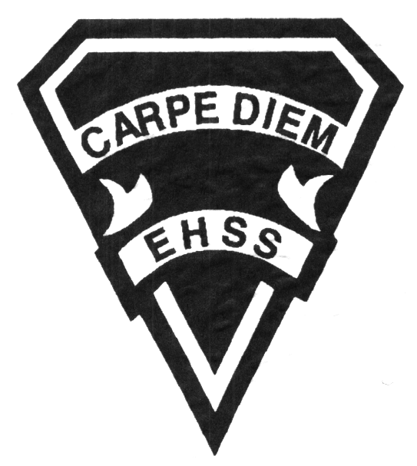

**Course Description/Rationale/Overview:**  Students will read and analyse a range of stimulating and provocative texts from various time periods, countries. This year the focus will be on Jewish authors. Students will also work with literary theory, and with understanding academic language and using it coherently and confidently in discussion and argument. Essay writing, particularly analytical and argumentative essays, will be reinforced and will lead to a major paper for an independent literary research project.

**Prerequisites:** Students need to like literature, be strong readers, and have English 11, University Preparation

# **ETS 4U1**

**Evaluation Profile and Outline**

### English Literature Grade 12 University

## Earl Haig

SecondarySchool

**Assessment and Evaluation Strategies**

**Assessment:** Checklists, rubrics, performances and demonstrations, teacher observation, teacher-student conferences, peer checklists, cooperative learning, visual or graphic organizers, self-evaluation, problem solving.

**Evaluation:** Tests and quizzes, media products personal response journals, written responses, supported opinion essays, oral presentations, timed in-class writing,

**Class Requirements:**

##### Student Responsibility

Students must seek assistance from fellow students and the teacher for all work missed due to absence and must make arrangements to complete missed work.

**Prerequisite:** English, Grade 11, University

**Course Requirements/Department Policies**

Late Assignments

Late assignments must be accompanied with a note signed by a parent or guardian stating the reason for tardiness of the assignment. The note must list the due date of the assignment and the actual date of submission.

If an assignment is handed in after it has been taken up/handed back, the student may not receive a mark for it.

Missed Tests

It is the student’s responsibility to make arrangements, ahead of time, for any tests/quizzes that are missed. If a student misses a test/quiz for an unforeseen reason such as illness, the student must bring a note signed by a parent or guardian and be prepared to write the test/quiz immediately upon return to school.

**Learning Skills\***

**Responsibility** – meets deadlines; takes responsibility for own behaviour

**Organization** – establishes priorities and manages time; uses information, technology and resources top complete tasks time management

**Independent Work** – follows instruction with minimal supervision; uses class time appropriately to complete tasks

**Collaboration** – accepts an equitable share of work in a group; builds healthy peer relationships; works with others to achieve group goals

**Initiative** – looks for opportunities for learning; demonstrates curiosity; approaches new tasks with a positive attitude

**Self-regulation** – sets own goals and monitors own progress; seeks assistance with needed; makes an effort with responding to challenges

###### Final Mark: Term Mark 70% Final Summative Evaluation 30%

Each term will be based on:

* Personal response journals
* Demonstration of critical-thinking skills
* Responses to literature and media
* Analysis of literary and dramatic techniques
* Creative, persuasive and informational writing, for different audiences

and purposes, in a variety of forms

* Revising writing, with a focus on ideas, clarity, accuracy and coherence
* Editing to produce final drafts, using the writing process

**Final Summative Evaluation 30%**

* June exam 15% (Based on Reading and Writing Skills)
* Summative project 15%

**Curriculum Strands and Weighting**

* **Reading** 30%
* **Writing** 30%
* **Oral literacy** 20%
* **Media Studies** 20%

*From: Ontario Ministry of Education. *Growing Success: Assessment, Evaluation, and Reporting in Ontario Schools*. Toronto: Ministry of Education, 2010, 11.



# **ETS 4U1**

**Evaluation Profile and Outline**

## Earl Haig

SecondarySchool

### English Literature Grade 12 University

###### Course Outline

# Some Texts

* Selections from the American Literature anthology
* Frye, Northrop. The Educated Imagination
* Kafka, Franz. The Metamorphosis
* Roth, Philip. Indignation,
* Safran-Foer, Jonathan. Everything is Illuminated
* Spiegelman, Art. Maus
* Richler, Mordecai. Barney's Version
* other significant, literary texts