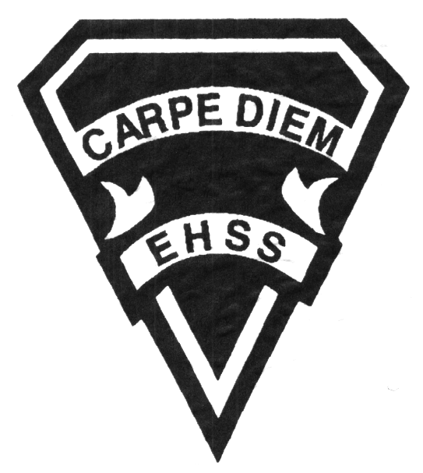

##### Grade 11

##### Film Arts Majors

# **AWS 3MP**

**Evaluation Profile & Outline**

**FILM MEDIA ARTS**

## Earl Haig

Secondary

School

**Course Description:** The areas of study for Grade 11 Film Arts will be taught in a combination of separate units and some integrated ones. Students will focus on honing their technical and storytelling abilities developed over the last two years in Film Arts. Emphasis will be placed on conceptual thinking and solid cinematography. Students will be challenged on multiple projects to showcase their abilities of storytelling, both conceptually and experimentally. Students will also start the development of their “voice” as filmmakers. This course prepares students with real time management skills, communication skills and group decision-making abilities. This course will focus on the theoretical approaches to various film classifications and projects with an emphasis on developing the preproduction components of all film projects. AWS3MP will working in conjunction with TGV3MP. Like all film projects, group work is essential, however, there will be a strong focus on individual work and evaluation.

**Evaluation, Mark Breakdown:**

Year’s Work: **70%**

Final Summative: **30%**

(During final six weeks of classes)

**LEARNING SKILLS: Responsibility** – meets deadlines; takes responsibility for own behaviour**. Organization** – establishes priorities and manages time; uses information, technology and resources top complete tasks time management**. Independent Work** – follows instruction with minimal supervision; uses class time appropriately to complete tasks**. Collaboration** – accepts an equitable share of work in a group; builds healthy peer relationships; works with others to achieve group goals. **Initiative** – looks for opportunities for learning; demonstrates curiosity; approaches new tasks with a positive attitude**. Self-regulation** – sets own goals, monitors own progress; seeks assistance when needed; makes an effort with responding to challenges

**LAB HOURS:** In addition to class time, the Communications Technology Lab will be open before and after school *upon student request*. Students missing any classes may also be asked to make up work at that time. **EQUIPMENT:** Students must get the parental permission form signed before borrowing any equipment. In this, they agree to be responsible for any loss or damage. ***All equipment must be returned by 8:30 am the next morning. Failure to return the equipment on time will result in loss of borrowing privileges.***

**Course Requirements and Department Policies:** Class Work – Students must come to class prepared to work on individual or group projects for the whole class. At times, students are expected to do extra work and perform duties related to the program outside of class time. That said, students must complete a minimum of 75% of the project in class to allow for teacher and class input.Tests & Assignments – It is the student’s responsibility to make arrangements for missed tests/projects and/or any class evaluated work. Students must have a valid reason for missed evaluations and produce an explanatory note that explains the reason why such an evaluation has been missed (example, a doctor’s note). Failure to communicate with teacher in advance and/or to not produce an explanatory note may result in a zero in the evaluation. **Also**, **students must adhere to the strict due dates of projects/assignments**. **Not adhering to the due dates not only compromises the student’s (and class’) final products but may have an effect on the student’s overall evaluation.** Studio Hours – In addition to class time, the Film Arts Studio will open after school *on request* for about 30 minutes. If longer times are needed they can be negotiated with a Film Arts teacher. Missed classes must be made up after school or during daytime open studio time.

**Class Requirements:** Each Student is required to have a dedicated notebook for this class. On-line resources are provided along with handouts and exemplars. Each student should have an external hard drive (500GB or more) used to back-up all class projects. Students may use their own equipment if they wish.

**Assessment and Evaluation Strategies:** Rubrics provided at the beginning of each unit outlining the expectations and time lines for the unit.

**Assessment:** Homework checks, peer assessment, presentations, reflection writing, teacher observation.

**Evaluation:** Tests, in class assignments/projects completed on time & according to the rubric provided.

**Achievement Categories and Weighting**

* **Knowledge / Understanding 20%**: knowledge of facts and terms; understanding of concepts, principles, guidelines and strategies; understanding of relationships among concepts.
* **Application 35%**: applied knowledge in completion of video and all other accompanying project elements that fulfills the project requirements
* **Thinking Inquiry 25%:** Formulating questions; planning, selecting strategies and resources; analyzing and interpreting information, and forming conclusions.
* **Communication 20%**:Communication of information and ideas, communication for different audiences, use of various forms of communication.

**UNITS OF STUDY:**

*All lessons are taught through an integration of the units of study. Lessons will fluctuate between each unit to better address filmmaking techniques and application in a more holistic manner. This course will be taught in conjunction with TGV3MP. Although all projects will have both an individual and group work evaluation,* emphasis will be placed on individual marks***. NOTE TGV3MP and AWS3MP courses are directly linked. The two courses share the same units and cover the same content. What will separate the two courses will be the delivery of the material and the evaluation of the final product. AWS3MP will concentrate on the theoretical approach to the units while TGV3MP will focus on applying the information learned to build amazing films. AWS3MP* will be evaluating the preproduction (idea/concept, screenplay, mood boards etc.) for each unit while TGV3MP will primarily evaluate the student(s) technical skills (filming, sound, editing etc.) in production and post-production for each unit.***

* *AWS3MP assignments and Film Projects will carry full “Pre-Production Evaluations”*

**UNIT 1: FILMMAKING FOR COMMERCIAL PURPOSES**

* Corporate Film and Commercial Film
* Communication Message
* Careers
* Challenges

**UNIT 2: FILMMAKING – INTERNET SENSATIONS**

* Viral Films - Meaning
* Communication Message
* Challenges

**UNIT 3: THE GIFT – INTER-MAJOR COLLABORATIVE PROJECT**

* Brainstorming – Message Meaning
* Experimental Concepts
* Challenges

**UNIT 4: ZOOM FILM**

* Storyline – Script – Shotlist / Storyboard
* Communication Message

**UNIT 5: MUSIC VIDEOS – FINAL CULMINATING PROJECT**

* History of Music Video
* Sound – Cinematography – Editing
* Communication Message – Storyline

**ACTIVITIES, HOMEWORK, ASSIGNMENTS, TESTS/QUIZZES AND PROJECTS:**

Each unit will present various challenges. In class activities are designed to grasp the content learned in class. Usually there will be 1 or 2 evaluated activity per unit plus one major project. Your utmost attention and participation is required.

**PLAGIARISM:**

Students are expected to submit only their own original work activities, assignments and projects done in or out of class. Plagiarism—falsely representing other’s work as your own—and academic dishonesty will be dealt with on a case-by-case basis, but will be investigated, and a mark of zero will be assigned for plagiarized work (see Student Agenda).