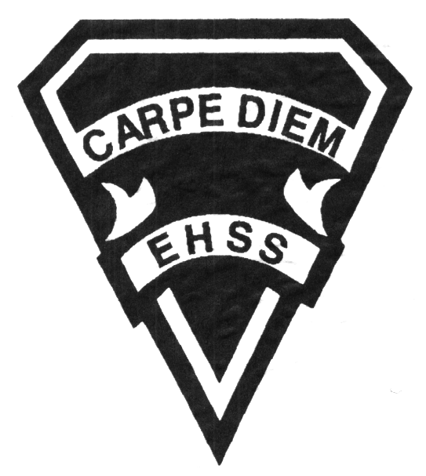

## Earl Haig

SecondarySchool

### AWQ2O2

##### Grade 10 Photography

##### Visual Arts

# **AWQ2O2**

**Evaluation Profile & Outline**

**Course Description/Rationale/Overview:**

This course is intended to expose students to a variety of photographic processes, techniques and applications. Students will explore and experiment with lighting, camera and darkroom techniques. They will incorporate technical exercises into a sketchbook and prepare final dry-mounted images ready for display.

**Assessment and Evaluation Strategies:**

Diagnostic, formative and summative: Rubrics

**Assessment:**

Student/teacher conferencing, group and self critiques, self/teacher check lists, observational assessments by teacher.

Artist statements, reflective writing and documentation of all process work.

**Evaluation:**

Process work, final projects/pieces, art history tests and quizzes, research assignments, art history presentations, in class and at home assignments.

**Class Requirements:**

Visual Arts Kit: See attached handout for specific materials required.

All kit materials will be provided for purchase in September in the Visual Arts department. (Date to be announced)

**Late and/or Missed Evaluation:**

The Visual Arts Department’s policy on late assignments as well as missed presentations and essays is in complete agreement with the school-wide policy. This policy adheres to the Ministry document Growing Success *(Pg. 43-46). Late assignments must be accompanied by a note signed by a parent or guardian, stating the reason for the tardiness of the assigned work. The note must specify the due date and the actual date of the submission. Should an assignment be handed in after it has been taken up/handed back, the student may not receive a mark for it.

**Subject-Specific/Department Information**

**Attendance & Punctuality:**

Attending all classes is mandatory as much of this course is studio driven. During class time, students are instructed (through demonstrations) on specific techniques and processes necessary for completing their works successfully. All classes begin with crucial lessons and hands on demonstrations. Lateness results in missed information. As well, it is disruptive and disrespectful to the class as a whole.

**Exhibitions:**

Students work toward photography shows at the end of the year and board wide exhibits.

**Learning Skills**

**Responsibility** – meets deadlines; takes responsibility for own behaviour

**Organization** – establishes priorities and manages time; uses information, technology and resources to complete tasks; time management

**Independent Work** – follows instruction with minimal supervision; uses class time appropriately to complete tasks

**Collaboration** – accepts an equitable share of work in a group; builds healthy peer relationships; works with others to achieve group goals

**Initiative** – looks for opportunities for learning; demonstrates curiosity; approaches new tasks with a positive attitude

**Self-regulation** – sets own goals and monitors own progress; seeks assistance when needed; makes an effort with responding to challenges

###### Final Mark

**Year’s Work 70%**

Studio and darkroom work, process work and projects, sketchbooks, take home assignments, artist statements, essays and presentations.

**Final Summative Evaluation 30%**

Final project includes proposal, shooting, processing, editing and printing of final images.

**Achievement Categories and Weighting**

* **Knowledge / Understanding 25 %** Knowledge and understanding of content (e.g. facts and terms; techniques; elements and principles; understanding of procedures, processes and conventions)
* **Thinking 25 %** Formulating questions; planning, selecting strategies and resources; analyzing and interpreting information, and forming conclusions.
* **Application 40 %** Application and transfer of knowledge and skills (e.g. composition, elements, principles, processes, technologies, techniques, strategies and conventions)
* **Communication 10 %** Clear expression and logical organization of information and ideas, in oral and written forms. (e.g. presentations, critiques, proposals and artist statements)

*From: Ontario Ministry of Education. *Growing Success: Assessment, Evaluation, and Reporting in Ontario Schools*. Toronto: Ministry of Education, 2010, 11.



## Earl Haig

SecondarySchool

### AWQ 2O2

##### Grade 10 Photography

**Visual Arts**

# **AWQ 2O2**

**Evaluation Profile & Outline**

**Course Outline/Curriculum Strands:**

**Creating & Presenting**

**A1. The Creative Process:** apply the creative process to create a variety of art works, individually and/or collaboratively;

**A2. The Elements and Principles of Design: apply** the principles of design to create art works for the purpose of self-expression and to communicate ideas, information, and /or messages;

**A3. Production and Presentation:** produce art works, using a variety of media/materials and traditional and/or emerging technologies, tools, and techniques, and demonstrate an understanding of a variety of ways of presenting their works and the works of others.

**Reflecting, Responding, and Analysing**

**A1. The Critical Analysis Process:** demonstrate an understanding of the critical analysis process by examining, interpreting, evaluating, and reflecting on various arts works;

**A2. Art, Society, and Values:** demonstrate an understanding of how art works reflect the society in which they were created, and how they can affect personal values;

**A3. Connections Beyond the Classroom:** demonstrate an understanding of the types of knowledge and skills developed in visual arts, and identify various opportunities related to visual arts.

**Foundations**

**A1. Terminology:** demonstrate an understanding of, and use correct terminology when referring to, elements, principles, and other components related to visual arts;

**A2. Conventions and Techniques:** demonstrate an understanding of the conventions and techniques used in the creation of visual art works;

**A3. Responsible Practices:** demonstrate an understanding of responsible practices related to visual arts.

**Photograms**

*Incorporating the Principles and Elements of Design, students use objects and/or cut outs to create a series of graphic black and white images with photographic paper and an enlarger. Students become familiar with the traditional black and white darkroom (enlargers and chemistry) and working with light sensitive material.*

**Architectural Light and Shadow**

*Students use 35mm film cameras and black and white film to photograph abstract images of the school’s architecture. Students are introduced to the camera controls (film speed, aperture and shutter speed) before shooting. Later students are introduced to the processing of images using traditional chemistry, making a contact sheet with their film negatives and finally, enlarging the images into a series of prints.*

**Motion / Blurred and Stop Action**

*Students explore the extremes of shutter speed. They are required to plan suitable subject matter / action to photograph a series of blurred images and images of stop action/frozen motion. Students process their film,make a contact print, test and final prints.*

**Portraiture and Lighting**

*Using window and tungsten light, students explore direction of light and how it affects mood and the form of the human face in a portrait. Students process their film, make a contact print, test and final prints.*

**History of Photography**

*Students research key historical individuals, discoveries, equipment and events in the world of photography and present it in written/oral form.*

**Memories of Space**

*Students plan and design a photographic shoot involving subject matter of their choice. Using the photographic skills learned throughout the year (camera controls, lighting, Principles and Elements of Design), students shoot a series of images that explore their chosen subject matter in a creative manner. Students process their film, make a contact sheet, test strip(s), and final prints.*