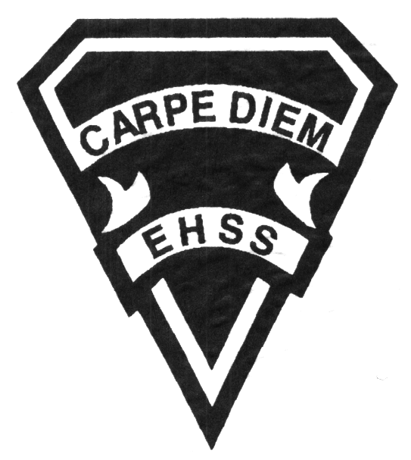

## Earl Haig

SecondarySchool

### AWN 3M1

##### Grade 11 Painting

##### Visual Arts

# **AWN 3M1**

**Evaluation Profile & Outline**

**Course Description/Rationale/Overview:**

This course is intended to expose students to a variety of painting processes, techniques and applications using acrylic paints and other mediums. As well, they will be familiarized with a variety of both historical and contemporary painters and their approaches to painting. Students will explore and experiment with colour theory, paint application, various surfaces to paint on, as well as mixed media. Students will also develop a body of process and analytical work through their sketchbooks and process folders.

**Assessment and Evaluation Strategies**

Diagnostic, formative and summative: Rubrics

**Assessment:**

Student/teacher conferencing, group and self critiques, self/teacher check lists, observational assessments by teacher.

Artist statements, reflective writing and documentation of all process work.

**Evaluation:**

Process work, final projects/pieces, art history tests and quizzes, research assignments, art history presentations, in class and at home assignments.

**Class Requirements:**

All paints, brushes, paper, canvas and board will be provided by the Visual Arts department. However, it is recommended, not mandatory, for students to have the primary colours as well as black and white, along with one large and one detail brush for home use.

Painting materials will be provided for purchase in September in the Visual Arts department. (Date to be announced)

**Late and/or Missed Evaluation**

Our policy on late assignments as well as missed presentations and essays is in complete agreement with the school-wide policy. This policy adheres to Growing Success,( Pg.43-46) Late assignments must be accompanied with a note signed by a parent or guardian, stating the reason for the tardiness of the assigned work. The note must specify the due date and the actual date of the submission. Should an assignment be handed in after it has been taken up/handed back, the student may not receive a mark for it.

**Learning Skills\***

**Responsibility** – meets deadlines; takes responsibility for own behaviour

**Organization** – establishes priorities and manages time; uses information, technology and resources top complete tasks time management

**Independent Work** – follows instruction with minimal supervision; uses class time appropriately to complete tasks

**Collaboration** – accepts an equitable share of work in a group; builds healthy peer relationships; works with others to achieve group goals

**Initiative** – looks for opportunities for learning; demonstrates curiosity; approaches new tasks with a positive attitude

**Self-regulation** – sets own goals and monitors own progress; seeks assistance with needed; makes an effort with responding to challenges

**Subject-Specific/Department Information**

**Attendance & Punctuality:** Attending all classes is mandatory as much of this course is studio driven. During class time, students are instructed (through demonstrations) on specific techniques and processes necessary for completing their works successfully. All classes begin with crucial lessons and hands on demonstrations. Lateness results in missed information. As well, it is disruptive and disrespectful to the class as a whole.

**Studio practice:** All final pieces and work executed for process folders will be done in class (unless specified by the teacher for smaller pieces).

Sketch book use will be ongoing.

###### Final Mark

**Year’s Work 70%**

Sketchbooks, studio work, projects, take home assignments, artist statements, essays and presentations.

Field trips and guest artist lectures.

*Attending field trips and lectures is mandatory.

**Final Summative Evaluation 30%**

Younger Self-Portrait Unit. *Final piece will be supported by sketchbook process exercises, in class and at home colour studies, photos, composition studies and an artist’s statement.*

**Achievement Categories and Weighting**

* **Knowledge / Understanding 25 % (Creating & Presenting)**: knowledge of facts and terms; understanding of concepts, principles, guidelines and strategies; understanding of relationships among concepts.
* **Application 40 % (Creating & Presenting)**: Processes, techniques and technologies. Final pieces ready for show.
* **Thinking Inquiry 25 % (Reflecting, Responding &Analyzing):** Formulating questions; planning, selecting strategies and resources; analyzing and interpreting information, and forming conclusions.
* **Communication 10 % (Foundations)**:Communication of information and ideas, communication for different audiences, use of various forms of communication.

*From: Ontario Ministry of Education. *Growing Success: Assessment, Evaluation, and Reporting in Ontario Schools*. Toronto: Ministry of Education, 2010, 11.

### AWN 3M1

##### Grade 11 Painting

**Visual Arts**



## Earl Haig

SecondarySchool

# **AWN 3M1**

**Evaluation Profile & Outline**

**Course Outline/Curriculum Strands:**

**Creating & Presenting**

**A1. The Creative Process:** apply the creative process to create a variety of art works, individually and/or collaboratively;

**A2. The Elements and Principles of Design: apply** the principles of design to create art works for the purpose of self-expression and to communicate ideas, information, and /or messages;

**A3. Production and Presentation:** produce art works, using a variety of media/materials and traditional and/or emerging technologies, tools, and techniques, and demonstrate and understanding of a variety of ways of presenting their works and the works of others.

**Reflecting, Responding, and Analysing**

**A1. The Critical analysis Process:** demonstrate an understanding of the critical analysis process by examining, interpreting, evaluating, and reflecting on various arts works;

**A2. Art, Society, and Values:** demonstrate an understanding of how art works reflect the society in which they were created, and how they can affect personal values;

**A3. Connections Beyond the Classroom:** demonstrate an understanding of the types of knowledge and skills developed in visual arts, and identify various opportunities related to visual arts.

**Foundations**

**A1. Terminology:** demonstrate an understanding of, and use correct terminology when referring to, elements, principles, and other components related to visual arts;

**A2. Conventions and Techniques:** demonstrate an understanding of the conventions and techniques used in the creation of visual art works;

**A3. Responsible Practices:** demonstrate an understanding of responsible practices related to visual arts.

**Title of Unit/Strand 1**

***Still Life-Lemon Painting***

This unit is an introduction to both the traditional as well as contemporary aspects of still life painting. Students will focus on a single lemon, positioned on a surface, with a single light source. Focus will be on accurate rendering, use of under-painting, depiction of light and colour. All work shall be supported by sketchbook process exercises, in class and at home colour studies, photos and composition studies

*Culminating Task: Still life of a lemon on a coloured background, using acrylics on panel..*

**Title of Unit/Strand 2**

***Photo-Realistic Food Painting***

This unit will take still life painting to the next level. Students will photograph food items and paint them on a large scale. Focus will be on accurate rendering, use of under painting, depiction of light and colour. All work shall be supported by sketchbook process exercises, in class and at home colour studies, photos and composition studies.

*Culminating task: Large scale photo-realistic painting of food.*

**Title of Unit/Strand 3**

***Surrealist Landscape***

This unit is an examination and deconstruction of the conventions of landscape painting. Students will employ a variety of techniques and media along with acrylics. Emphasis will be placed on the use of photo references, mixed media, spray paint, collage, India Ink and opaque and transparent uses of acrylics. Final piece will be supported by sketchbook process exercises, in class and at home colour studies, photos and composition studies.

*Culminating Task: Acrylic painting of a landscape, using mixed media and acrylics on canvas.*

**Title of Unit/Strand 4**

***Art History- A Painter***

An in depth study of the works of a single painter from a broad timeline of art history. The (re)production of an appropriated painting from the same painter with strategic additions and omissions.

*Culminating Task: Power point presentations done individually, addressing the background, style, imagery, influence and appeal of a particular painter from the time line provided.*

**Title of Unit/Strand 5 - Summative**

***Younger Self-Portrait***

This unit has students examine their “younger selves” by painting a monochromatic self-portrait and incorporating various personal imagery and text. Final piece will be supported by sketchbook process exercises, in class and at home colour studies, photos and composition studies and an artist statement.

*Culminating task: Large scale painting which includes a black and white portrait of the artist as a child and various personal imagery and text.*