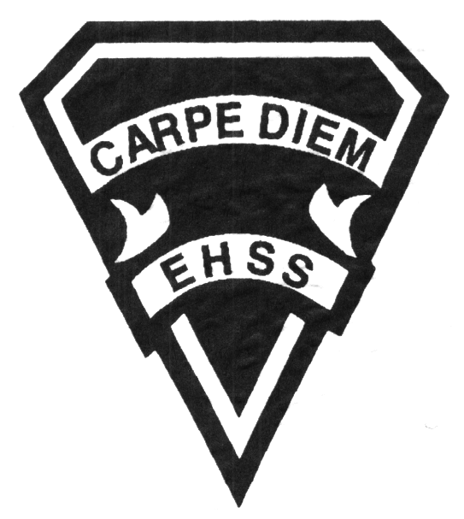

## Earl Haig

SecondarySchool

### AVI 4M1

##### Grade 12 Electives

**Visual Arts**

# **AVI 4M1**

**Evaluation Profile & Outline**

**Course Description/Rationale/Overview:**

This course focuses on enabling students to refine their use of the creative process when creating and presenting art works using a variety of traditional and emerging media and technologies. Students are expected to develop a personal portfolio of work through increasingly self-directed strategies. Curatorial practices, art history and art theory are an integral part of this course.

**Assessment and Evaluation Strategies**

Diagnostic, formative and summative: Rubrics

**Assessment:**

Student/teacher conferencing, group and self critiques, self/teacher check lists, observational assessments by teacher.

Artist statements, reflective writing and documentation of all process work.

**Evaluation:**

Process work, final projects/pieces, art history tests and quizzes, research assignments, art history presentations, in class and at home assignments.

**Class Requirements:**

Visual Arts Kit: See attached handout for specific materials required.

All kit materials will be provided for purchase in September in the Visual Arts department. (Date to be announced)

**Late and/or Missed Evaluation**

Our policy on late assignments as well as missed presentations and essays is in complete agreement with the school-wide policy. This policy adheres to Growing Success (Pg. 43-46). Late assignments must be accompanied with a note signed by a parent or guardian, stating the reason for the tardiness of the assigned work. The note must specify the due date and the actual date of the submission. Should an assignment be handed in after it has been taken up/handed back, the student may not receive a mark for it.

**Subject-Specific/Department Information**

**Attendance & Punctuality:** Attending all classes is mandatory as much of this course is studio driven. During class time, students are instructed (through demonstrations) on specific techniques and processes necessary for completing their works successfully. All classes begin with crucial lessons and hands on demonstrations. Lateness results in missed information. As well, it is disruptive and disrespectful to the class as a whole.

**Student leadership and exhibitions:** The Curatorial Project, ongoing student-lead exhibitions in the Wave Gallery, off-site end of year show.

**Learning Skills\***

**Responsibility** – meets deadlines; takes responsibility for own behaviour

**Organization** – establishes priorities and manages time; uses information, technology and resources top complete tasks time management

**Independent Work** – follows instruction with minimal supervision; uses class time appropriately to complete tasks

**Collaboration** – accepts an equitable share of work in a group; builds healthy peer relationships; works with others to achieve group goals

**Initiative** – looks for opportunities for learning; demonstrates curiosity; approaches new tasks with a positive attitude

**Self-regulation** – sets own goals and monitors own progress; seeks assistance with needed; makes an effort with responding to challenges

###### Final Mark

**Year’s Work 70%**

Sketchbooks, studio work, projects, take home assignments, artist statements, essays and presentations.

**Final Summative Evaluation 30%**

Final project –Creation and gallery installation of three works on a theme chosen by the student in consultation with the teacher.

**Achievement Categories and Weighting**

* **Knowledge / Understanding 25 % (Creating & Presenting)**: knowledge of facts and terms; understanding of concepts, principles, guidelines and strategies; understanding of relationships among concepts.
* **Application 40 % (Creating & Presenting)**: Processes, techniques and technologies. Final pieces ready for show.
* **Thinking Inquiry 25 % (Reflecting, Responding &Analyzing):** Formulating questions; planning, selecting strategies and resources; analyzing and interpreting information, and forming conclusions.
* **Communication 10 % (Foundations)**:Communication of information and ideas, communication for different audiences, use of various forms of communication.

*From: Ontario Ministry of Education. *Growing Success: Assessment, Evaluation, and Reporting in Ontario Schools*. Toronto: Ministry of Education, 2010, 11.



## Earl Haig

SecondarySchool

### AWT 4MP

##### Grade 12 Majors

**Visual Arts**

# **AVI 4M1**

**Evaluation Profile & Outline**

**Course Outline/Curriculum Strands:**

**Creating & Presenting**

**A1. The Creative Process:** apply the creative process to create a variety of art works, individually and/or collaboratively;

**A2. The Elements and Principles of Design: apply** the principles of design to create art works for the purpose of self-expression and to communicate ideas, information, and /or messages;

**A3. Production and Presentation:** produce art works, using a variety of media/materials and traditional and/or emerging technologies, tools, and techniques, and demonstrate and understanding of a variety of ways of presenting their works and the works of others.

**Reflecting, Responding, and Analysing**

**A1. The Critical analysis Process:** demonstrate an understanding of the critical analysis process by examining, interpreting, evaluating, and reflecting on various arts works;

**A2. Art, Society, and Values:** demonstrate an understanding of how art works reflect the society in which they were created, and how they can affect personal values;

**A3. Connections Beyond the Classroom:** demonstrate an understanding of the types of knowledge and skills developed in visual arts, and identify various opportunities related to visual arts.

**Foundations**

**A1. Terminology:** demonstrate an understanding of, and use correct terminology when referring to, elements, principles, and other components related to visual arts;

**A2. Conventions and Techniques:** demonstrate an understanding of the conventions and techniques used in the creation of visual art works;

**A3. Responsible Practices:** demonstrate an understanding of responsible practices related to visual arts.

**Acrylic Painting/Strand 1**

An introduction to acrylic paint as a vehicle of achieving both realism as well as exploratory on-representational works. Some of the techniques explored in this unit will include: blending, colour mixing, expressive brush handling.

Culminating task: Still life composition of object chosen by student in consultation with the teacher, using acrylic paint on prepared canvas.

Final piece will be supported by sketchbook drawing and painting process exercises and practice canvas, in class activities/experimentation with the medium, photos and composition studies.

**Conceptual—Various Media/Strand 1**

**Personal choice of 10 Conceptual Projects**

Students will continue to experiment with video, photography, sound-works, object-based works, transfers, embossing, as well as traditional media

Culminating task: Students will brainstorm, plan and execute an artwork in the medium of their choice

Final piece will be supported by sketchbook drawing and experimentation with different media, artist statements, and critique.

**The Book Project/Strand 2**

**Sculpture**

An exploration of the book as an art form.

Culminating Task: research, plan and create an original work of art in any media that thoroughly analyses the role of a book in the student’s opinion.

Final piece will be supported by technical creation of a handmade book, sketchbook drawing, research.

**Art History/Strand 3**

**Isms Essay**

A comprehensive comparative analysis of two key artistic movements from Neoclassical to present day.

Culminating Task: Written essay/research project.

**Conceptual Various Media/Strand 4**

**Personal choice of 10 Conceptual Projects**

This project provides the students with an opportunity to further build their portfolio by the creation of an artwork in the media of their choice.

Culminating task: Students will brainstorm, plan and execute an artwork in the medium of their choice

Final piece will be supported by sketchbook drawing and experimentation with different media, artist statements, and critique.

**Self-directed Series of Artworks/Strand 6 SUMMATIVE**

This unit brings together various techniques and mediums explored throughout the year.

Culminating task: Students will plan, design and create a series of related artworks that reflect their personal style and install in their chosen area of the school.