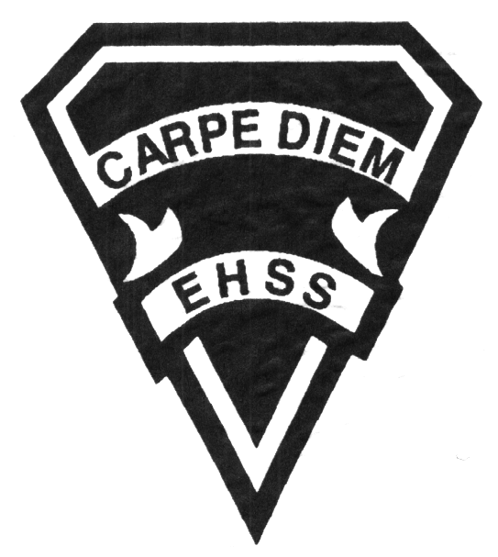

## Earl Haig

SecondarySchool

### AVI 2O1

##### Grade 10 Electives

##### Visual Arts

# **AVI 2O1**

**Evaluation Profile & Outline**

**Course Description/Rationale/Overview:**

This course is intended to expose students to a wide variety of visual arts processes, techniques and media while building on the foundations of the grade 9 course. Students will explore and experiment with design, drawing, painting, printmaking, sculpture and art history while developing a body of process and analytical work through their sketchbooks.

**Assessment and Evaluation Strategies**

Diagnostic, formative and summative: Rubrics

**Assessment:**

Student/teacher conferencing, group and self critiques, self/teacher check lists, observational assessments by teacher.

Artist statements, reflective writing and documentation of all process work.

**Evaluation:**

Process work, final projects/pieces, art history tests and quizzes, research assignments, art history presentations, in class and at home assignments.

**Class Requirements:**

Visual Arts Kit: See attached handout for specific materials required.

All kit materials will be provided for purchase in September in the Visual Arts department. (Date to be announced)

**Late and/or Missed Evaluation**

Our policy on late assignments as well as missed presentations and essays is in complete agreement with the school-wide policy. This policy adheres to Growing Success,( Pg.43-46 ) Late assignments must be accompanied with a note signed by a parent or guardian, stating the reason for the tardiness of the assigned work. The note must specify the due date and the actual date of the submission. Should an assignment be handed in after it has been taken up/handed back, the student may not receive a mark for it.

**Learning Skills\***

**Responsibility** – meets deadlines; takes responsibility for own behaviour

**Organization** – establishes priorities and manages time; uses information, technology and resources top complete tasks time management

**Independent Work** – follows instruction with minimal supervision; uses class time appropriately to complete tasks

**Collaboration** – accepts an equitable share of work in a group; builds healthy peer relationships; works with others to achieve group goals

**Initiative** – looks for opportunities for learning; demonstrates curiosity; approaches new tasks with a positive attitude

**Self-regulation** – sets own goals and monitors own progress; seeks assistance with needed; makes an effort with responding to challenges

**Subject-Specific/Department Information**

**Attendance & Punctuality:** Attending all classes is mandatory as much of this course is studio driven. During class time, students are instructed (through demonstrations) on specific techniques and processes necessary for completing their works successfully. All classes begin with crucial lessons and hands on demonstrations. Lateness results in missed information. As well, it is disruptive and disrespectful to the class as a whole.

**Participatory exhibitions:** ongoingWave Gallery exhibits, and May Visual Arts off-site exhibition.

###### Final Mark

**Year’s Work 70%**

Sketchbooks, studio work, projects, take home assignments, artist statements, essays and presentations.

**Final Summative Evaluation 30%**

Sculptural piece using unconventional materials.

**Achievement Categories and Weighting**

* **Knowledge / Understanding 25 % (Creating & Presenting)**: knowledge of facts and terms; understanding of concepts, principles, guidelines and strategies; understanding of relationships among concepts.
* **Application 40 % (Creating & Presenting)**: Processes, techniques and technologies. Final pieces ready for show.
* **Thinking Inquiry 25 % (Reflecting, Responding &Analyzing):** Formulating questions; planning, selecting strategies and resources; analyzing and interpreting information, and forming conclusions.
* **Communication 10 % (Foundations)**:Communication of information and ideas, communication for different audiences, use of various forms of communication.

*From: Ontario Ministry of Education. *Growing Success: Assessment, Evaluation, and Reporting in Ontario Schools*. Toronto: Ministry of Education, 2010, 11.



## Earl Haig

SecondarySchool

### AVI 2O1

##### Grade 10 Electives

**Visual Arts**

# **AVI 2O1**

**Evaluation Profile & Outline**

**Course Outline/Curriculum Strands:**

**Creating & Presenting**

**A1. The Creative Process:** apply the creative process to create a variety of art works, individually and/or collaboratively;

**A2. The Elements and Principles of Design: apply** the principles of design to create art works for the purpose of self-expression and to communicate ideas, information, and /or messages;

**A3. Production and Presentation:** produce art works, using a variety of media/materials and traditional and/or emerging technologies, tools, and techniques, and demonstrate and understanding of a variety of ways of presenting their works and the works of others.

**Reflecting, Responding, and Analysing**

**A1. The Critical analysis Process:** demonstrate an understanding of the critical analysis process by examining, interpreting, evaluating, and reflecting on various arts works;

**A2. Art, Society, and Values:** demonstrate an understanding of how art works reflect the society in which they were created, and how they can affect personal values;

**A3. Connections Beyond the Classroom:** demonstrate an understanding of the types of knowledge and skills developed in visual arts, and identify various opportunities related to visual arts.

**Foundations**

**A1. Terminology:** demonstrate an understanding of, and use correct terminology when referring to, elements, principles, and other components related to visual arts;

**A2. Conventions and Techniques:** demonstrate an understanding of the conventions and techniques used in the creation of visual art works;

**A3. Responsible Practices:** demonstrate an understanding of responsible practices related to visual arts.

**Title of Unit/Strand 1**

***Tonal Drawing: Tools***

This unit builds on tonal/pencil studies, introducing new media to create a representational depiction of tools.Final piece will be supported by extensive sketchbook process drawings and composition studies.

*Culminating Task: Drawing of several tools, using pencil on Stonehenge paper.*

**Title of Unit/Strand 2**

***Water Colour Collections Painting***

Students will select personal objects with a common theme. They will study traditional water colour techniques and rules of composition to showcase their collection in their painting.

*Culminating Task: A water colour painting depicting a personal collection.*

**Title of Unit/Strand 3**

***Art History- Art/Architecture from the 10th-18th Century***

An in depth study of western art/architecture created between the era of Gothic and Rococo art.

*Culminating Task: Power point presentations done in groups, covering one of the topics from provided time line; appropriation of a piece of artwork.*

**Title of Unit/Strand 4**

***Introduction to Concept-based artworks—The Object Project***

Introduction to contemporary artists/artworks through images and readings will support the students’ development. Students will further develop their ability to articulate their ideas behind their work and those of their colleagues through artist statements and group critique. Final piece will be supported by sketchbook drawing, in class activities and experimentation with different media.

*Culminating Task: The creation/alteration/manipulation of an object / objects in order to create a sculpture that brings attention to the objects’ form.*