EARL HAIG SECONDARY SCHOOL
Parent Teacher Interviews
November 1st, 2022
Dear Parents/Guardians:
On Thursday November 17th, 2022, we will be hosting our first Parent Teacher Interview day for the 2022 - 2023 school year. There will be no classes on November 17th as interviews will commence at 10:00 a.m. and conclude at 8:00 p.m. Interview times are available between 10:00 - 12:00 noon, 1:00 - 4:00 p.m. and 6:00 - 8:00 p.m. on November 17th for your convenience.
Booking of appointments to meet with your child’s teacher(s) will be done online at http://earlhaig.ca/interview/ . Online booking of appointment(s) for parent teacher interviews will be open on Earl Haig’s website from Thursday November 10th, at 12:01 a.m. and will remain open until Tuesday, November 15th, at 11:59 p.m. Please follow the link on the website to book your appointment(s). To book an appointment to meet with your child’s teacher(s) you are required to first create an account in order to login. You must register each year as the system is reset in October for security reasons. Please consult with your child on their schedule in order to determine the names of their teachers and courses.
We encourage you to book appointments with teachers for Parent Interview Night and to take this opportunity to check on your child’s progress. You and your child are invited to meet with the teachers in 10 minute private interviews during the morning, afternoon or evening time blocks. Please allow time in between appointments for moving from one interview to another. Please stick to the time format in order to allow all parents to meet with teachers as per schedule.
A help file outlining detailed instructions for booking of appointments online is provided on Earl Haig’s website. You can either print this file or open it and follow the online booking process outlined.
Parent Teacher Interviews November 17 , 2022.

Parent Teacher Interview Schedule:
10:00 - 12:00 Session 1
1:00 - 4.00 Session 2
6:00 - 8:00 Session 3
Parents will be seen from 10 -12 noon, 1- 4pm and then again from 6pm to 8:00 p.m. on November 17th. Appointments will be 10 minutes each.

All appointments will be made online through our website.
Look for the link on the main page of www.earlhaig.ca

Late start on November 29th, 2013.

The process of booking appointments is as follows:

- Click on the link to the parent/teacher interview from Earlhaig.ca main webpage or type in the following address in your internet browser – http://earlhaig.ca/interview/

- Click on Register Now to create an account in order to login. YOU MUST REGISTER EACH YEAR AS THE SYSTEM IS RESET TO MAINTAIN SYSTEM SECURITY.
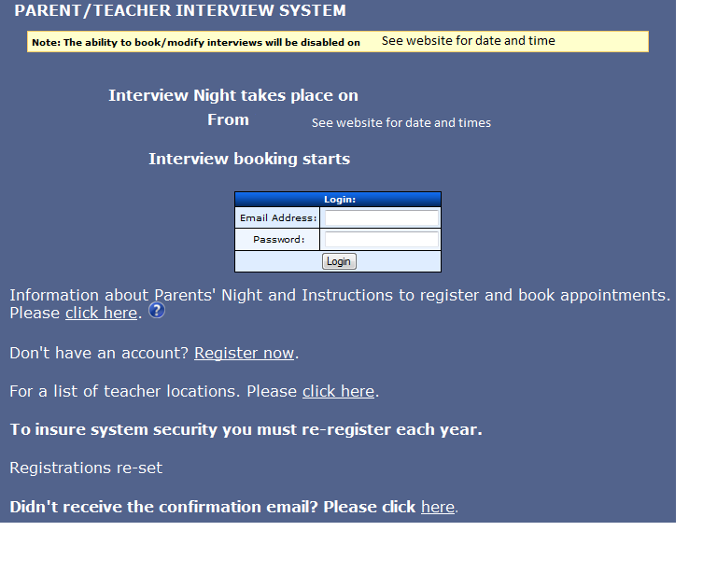

- Fill in all fields (please provide a valid email address) and click the Register button. Please do not click the Add button unless you have another child to add. If you accidentally click the Add button you must click the reset button and re-enter your child’s name. You can also add another child after registering (see M below). A confirmation email will be sent to the email account you provided.
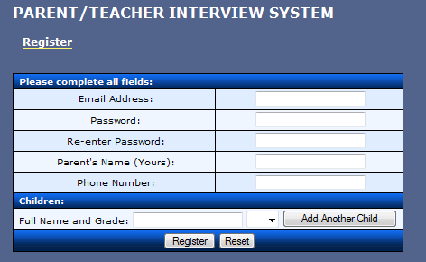

- Go to your email account and follow the confirmation email link to confirm your account.
- Click on login to go to the login page.
- Use your account information (email address and password) to login to the parent /teacher interview page.
- Click on Add an Interview to go to the teacher selection page.

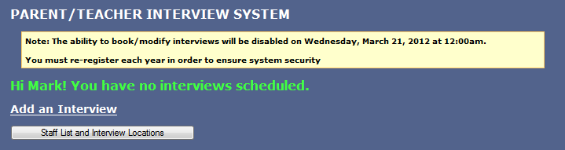

(to be announced)

Click
Add an Interview

H. Select the teacher from the drop down menu and enter the subject to book an appointment.
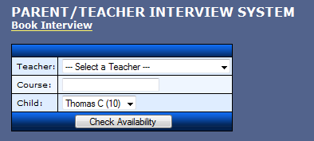
Click drop down menu to select a teacher.

Click Check Availability to select a time slot.

- Select a time slot using the drop down menu “Available Slots”.
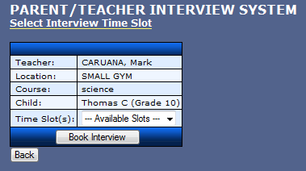

- Click the confirm button to confirm your interview time with the teacher.
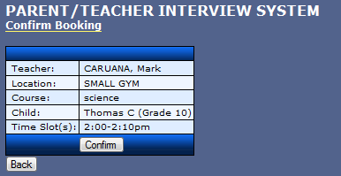

Confirm your interview

The following confirmation will then be shown.
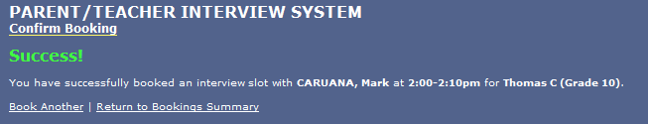

- Click Book Another and repeat steps H, I and J to book additional interview(s) with other teachers

- Clicking on the Return to Booking Summary button will display a page showing your interview(s) schedule. Your may edit your interviews here. If you need to remove one of the appointments you made then click the “delete” button on the row for that appointment (see the diagram below) and then click “Submit Changes”. This will just delete the one appointment and the rest will still be there.
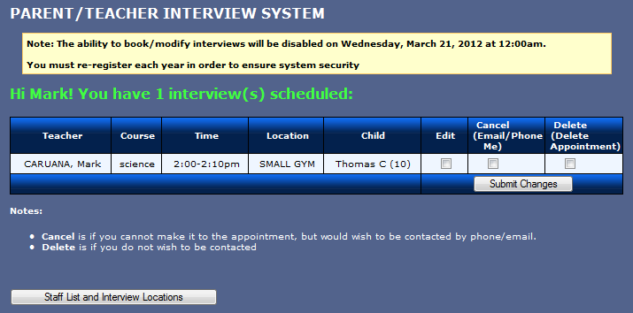

(to be announced)

M. If you select edit account on the left menu, you can change your password, contact info or add another child. You may also PRINT your appointments using the menu on the left.
