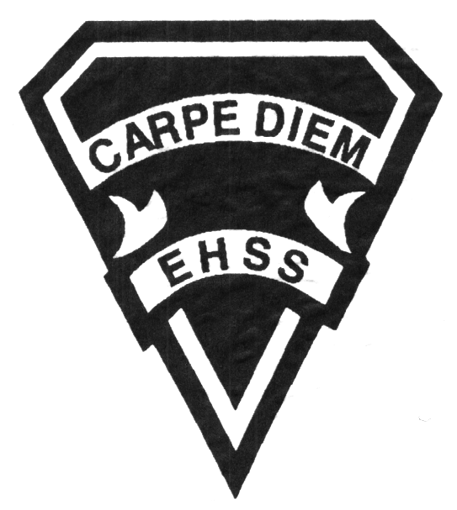

**Course Description/Rationale/Overview:**

This course enables students to develop a deeper understanding of concepts in biology, chemistry, earth and space science, and physics; to develop further their skills in scientific inquiry; and to understand the interrelationships among science, technology, and the environment. Students will conduct investigations and understand scientific theories.

**Prerequisite:** Science, Grade 9 Academic

## Earl Haig

SecondarySchool

# **SNC2D1/3/8**

**Evaluation Profile & Outline**

### SNC 2D Grade 10

##### University Preparation

**Science Department**

**Class Requirements:**

Students should have the following minimum supplies:

3 ring binder, loose-leaf paper, graph paper, scientific calculator, pen(s), pencil(s), ruler protractor and scissors.

**Assessment and Evaluation Strategies**

**Assessment:** Students will be evaluated using a variety of strategies including: practice quizzes, in-class assignments, homework, and self/peer marking.

**Evaluation:** Students will be evaluated using a variety of strategies such as: tests, quizzes, lab reports, lab skills, performance tasks, essays, and presentations. Assessment and evaluation will be based on the provincial curriculum expectations and the achievement levels on the achievement chart outlined in ministry curriculum documents.

**Late Assignments** - Late Assignments must be accompanied with a note signed by a parent or guardian stating the reason for the assignment being late. The note must list the due date of the assignment and the actual date of submission. If an assignment is handed in after it has been taken up/handed back, the student will get a mark of zero. Teachers may also impose a penalty for late assignments, at their discretion.

##### TESTS- Attendance during tests is mandatory unless a pre-arrangement is made with the teacher. Failure to do so may result in a mark of zero for the student. If a student misses a test/quiz for an unforeseen reason such as illness, the student must CONTACT THE TEACHER IMMEDIATELY. A makeup test (usually in a different format than the original test) will immediately follow the test dates unless you have made an alternate arrangement with your teacher. In order to write this test you must have a note signed by a parent or guardian (indicating that the parent is aware of the missed test/quiz). On repeat occurrences you will be asked to provide a doctors’ note. Failure to make contact and arrangements with your teacher for a missed test may result in a mark of Zero. Once a test/quiz has been taken up/handed back the student will receive a mark of zero.

**Textbook**

The course textbook is "Science 10". The replacement cost is $80.00. It is the student’s responsibility to return the same textbook they signed out. If their textbook is not returned, the replacement cost must be paid before a new textbook is issued. Students failing to return their textbook or pay the replacement fee will not receive a new textbook for the following school year, until their textbook is returned or the replacement cost is paid.

**Learning Skills\***

**Responsibility** – meets deadlines; takes responsibility for own behaviour

**Organization** – establishes priorities and manages time; uses information, technology and resources top complete tasks time management

**Independent Work** – follows instruction with minimal supervision; uses class time appropriately to complete tasks

**Collaboration** – accepts an equitable share of work in a group; builds healthy peer relationships; works with others to achieve group goals

**Initiative** – looks for opportunities for learning; demonstrates curiosity; approaches new tasks with a positive attitude

**Self-regulation** – sets own goals and monitors own progress; seeks assistance with needed; makes an effort with responding to challenges

*From: Ontario Ministry of Education. *Growing Success: Assessment, Evaluation, and Reporting in Ontario Schools*. Toronto: Ministry of Education, 2010, 11.



## Earl Haig

SecondarySchool

**2018/2019**

### SNC 2D Grade 10

##### University Preparation

**Science Department**

**Science Department**

# **SNC2D1/3/8**

**Evaluation Profile & Outline**

###### Final Mark

**Year’s Work 70%**

**Final Summative Evaluation 30%**

Final Exam -20%

Summative Project -10%

**Achievement Categories and Weighting**

* **Knowledge / Understanding 20 %**: knowledge of facts and terms; understanding of concepts, principles, guidelines and strategies; understanding of relationships among concepts.
* **Application (Making Connections) 10 %**: connection of concepts to everyday life.
* **Thinking/Inquiry 25 %:** Problem solving, formulating questions; planning, selecting strategies and resources; analyzing and interpreting information, and forming conclusions.
* **Communication 15%**:Communication of information and ideas, communication for different audiences, use of various forms of communication with respect to the assigned topic.

Teacher Info: ______________________________________________________________________________

______________________________________________________________________________

Student Signature: _______________________________ Date:____________________________

Parent Signature: _________________________________ Date: ___________________________

**Course Outline/Curriculum Strands:**

***Biology***

* Plants and animals, including humans, are made of specialized cells, tissues, and organs

that are organized into systems.

* Developments in medicine and medical technology can have social and ethical implications.

***Chemistry***

* Chemicals react with each other in predictable ways.
* Chemical reactions may have a negative impact on the environment, but they can also

be used to address environmental challenges.

***Physics***

* Light has characteristics and properties that can be manipulated with mirrors and

lenses for a range of uses.

* Society has benefited

***Earth and Space Science***

* Earth’s climate is dynamic and is the result of interacting systems and processes.
* Global climate change is influenced by both natural and human factors.
* Climate change affects living things and natural systems in a variety of ways.
* People have the responsibility to assess their impact on climate change and to identify

effective courses of action to reduce this impact.