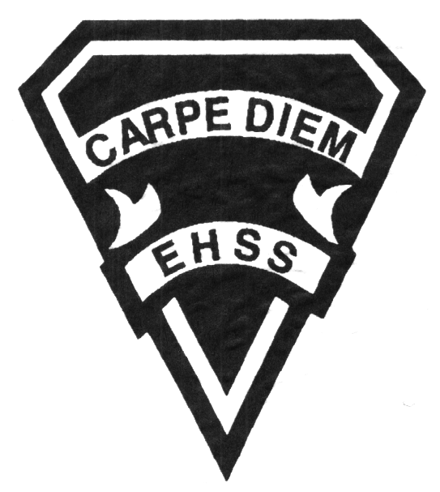

**Course Description/Rationale/Overview:**

This course focuses on the processes that occur in biological systems. Students will learn concepts and theories as they conduct investigations in the areas of cellular biology, microbiology, genetics, the anatomy of mammals, and the structure of plants and their role in the natural environment. Emphasis will be placed on the practical application of concepts, and on the skills needed for further study in various branches of the life sciences and related fields.

**Prerequisite:** Science, Grade 10, Academic or Applied

## Earl Haig

SecondarySchool

##### Grade 11 Biology

College Preparation

**Science Department**

# **SBI3C1**

**Evaluation Profile & Outline**

**Class Requirements:**

**Materials /Equipment**

Students should have the following minimum supplies: 3 ring binder, loose-leaf paper, graph paper, calculator, pen(s), pencil(s), ruler and scissors.

**Textbook**

The course textbook is "McGraw-Hill Ryerson Biology 11: College Preparation". The replacement cost is $90.00. It is the student’s responsibility to return the same textbook they signed out. If a textbook is lost, the replacement cost must be paid before a new book is issued. Students failing to return their textbook or pay the replacement fee will not receive a new textbook for the following school year, until their textbook is returned or the replacement cost is paid.

**Assessment and Evaluation Strategies**

**Assessment:**

Students will be evaluated using a variety of strategies including: practice quizzes, in-class assignments, homework, and self/peer marking.

**Evaluation:**

Students will be evaluated using a variety of strategies such as: tests, quizzes, lab reports, lab skills, performance tasks, essays, and presentations. Assessment and evaluation will be based on the provincial curriculum expectations and the achievement levels on the achievement chart outlined in ministry curriculum documents.

**Late and/or Missed Evaluation**

**1) Late Assignments** - Late Assignments must be accompanied with a note signed by a parent or guardian stating the reason for tardiness of the assignment. The note must list the due date of the assignment and the actual date of submission. If an assignment is handed in after it has been taken up/handed back, the student will get a mark of zero. Teachers may also impose a penalty for late assignments, at their discretion.

##### 2) TESTS- Attendance during tests is mandatory unless a pre-arrangement is made with the teacher. Failure to do so may result in a mark of zero for the student.

If a student misses a test/quiz for an unforeseen reason such as illness, the student must CONTACT THE TEACHER IMMEDIATELY. For course unit tests, a makeup test (usually in a different format than the original test) will immediately follow the test dates unless you have made an alternate arrangement with your teacher. In order to write this test you must have a note signed by a parent or guardian (indicating that the parent is aware of the missed test/quiz). On repeat occurrences you will be asked to provide a doctors’ note. **Failure to make contact and arrangements with your teacher for a missed test may result in a mark of Zero. Once a test/quiz has been taken up/handed back the student will receive a mark of zero.**

**3) *Missed Exam*** - If a student misses the Final Exam or any component of the final summative evaluation, they must bring in a medical certificate explaining their absence or make prior arrangements with their teacher in order to avoid a mark of zero.

**Subject-Specific/Department Information**

Science office Room 345

416-395-3210 ext. 20095

Textbook available online: @ www.earlhaig.ca/department/science/science department downloads/science password file/biology college/McGraw-Hill Ryerson College Biology text.

* **Summative Task details will be available in March**

**Learning Skills\***

**Responsibility** – meets deadlines; takes responsibility for own behaviour

**Organization** – establishes priorities and manages time; uses information, technology and resources top complete tasks time management

**Independent Work** – follows instruction with minimal supervision; uses class time appropriately to complete tasks

**Collaboration** – accepts an equitable share of work in a group; builds healthy peer relationships; works with others to achieve group goals

**Initiative** – looks for opportunities for learning; demonstrates curiosity; approaches new tasks with a positive attitude

**Self-regulation** – sets own goals and monitors own progress; seeks assistance with needed; makes an effort with responding to challenges

*From: Ontario Ministry of Education. *Growing Success: Assessment, Evaluation, and Reporting in Ontario Schools*. Toronto: Ministry of Education, 2010, 11.



## Earl Haig

SecondarySchool

### Grade 11 Biology

##### College Preparation

**Science Department**

# **SBI3C1**

**Evaluation Profile & Outline**

###### Final Mark

**Year’s Work 70%**

**Final Summative Evaluation 30%**

Final Exam - 20%

Summative Task -10%

**Achievement Categories and Weighting**

* **Knowledge / Understanding 20%**: knowledge of facts and terms; understanding of concepts, principles, guidelines and strategies; understanding of relationships among concepts.
* **Application 10%**: Connection of concepts to everyday life.
* **Thinking Inquiry 25%:** Formulating questions; planning, selecting strategies and resources; analyzing and interpreting information, and forming conclusions.
* **Communication 15%**:Communication of information and ideas, communication for different audiences, use of various forms of communication.

**Course Outline/Curriculum Strands:**

***Genetics***

* Demonstrate an understanding of the process of meiosis, and explain the role of genes in the transmission of hereditary characteristics.
* Investigate the process of meiosis, and analyse data related to the laws of heredity.
* Evaluate some social, ethical, and environmental implications of genetic research and related technologies.

***Microbiology***

* Demonstrate an understanding of the diversity of microorganisms and the relationships that exist between them.
* Investigate the development and physical characteristics of microorganisms, using appropriate laboratory equipment.
* Assess the effects of microorganisms in the environment, and analyse ethical issues related to their use in biotechnology.

***Anatomy of Mammals***

* Demonstrate an understanding of the structure, function, and interactions of the circulatory, digestive, and

respiratory systems of mammals.

* Investigate, through laboratory inquiry or computer simulation, the anatomy, physiology, and response mechanisms of mammals.
* Analyse the social or economic impact of a technology used to treat systems in the human body, and the impact of lifestyle choices on human health.

***Plants in the Natural Environment***

* Demonstrate an understanding of the structure and physiology of plants and their role in the natural environment.
* Investigate some of the factors that affect plant growth.
* Analyse the roles of plants in ecosystems, and assess the impact of human activities on the balance of plants within those ecosystems.

***Cellular Biology***

* Demonstrate an understanding of the basic processes of cellular biology
* Investigate the structures and functions of cells, and the factors that influence cellular activity, using appropriate laboratory equipment and techniques.
* Evaluate the impact of environmental factors and medical technologies on certain cellular processes that occur in the human body.

Teacher Info: ______________________________________________________________________________

______________________________________________________________________________

Student Signature: _______________________________ Date:____________________________

Parent Signature: _________________________________ Date: ___________________________

Teacher Info: ______________________________________________________________________________

______________________________________________________________________________

Student Signature: _______________________________ Date:____________________________

Parent Signature: _________________________________ Date: ___________________________