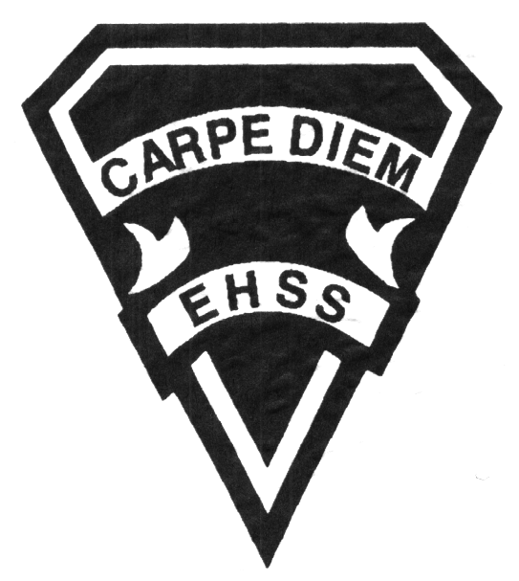

ATC 1O1

Evaluation Profile & Outline

ATC 1O1
Gr. Nine Dance Elective

Earl Haig
Secondary
School

Course Description/Rationale/Overview: This course requires the student to mentally and actively/physically participate in the daily structure of a mixed styles dance class. Students will learn world dance, jazz, contemporary, ballet & expressive forms of dance as ways to create dances. The students will learn and demonstrate about health and fitness in dance, stage craft, dance history and will perform in our annual Dance Collective Night. Students will also reflect on their learning, through oral, written critiques and dance demonstrations or presentations.

Class Requirements:

- DanceWear
Hair pulled back and off the neck. Black tights or yoga pants, and the ‘Dance Department Tee-shirt.’
Guys: Black dance pants and the ‘Dance Department Tee-shirt.’
- Lost costume: Replacement cost: $75 - $125

Assessment and Evaluation Strategies:

- Diagnostic
- Formative
- Summative

Project & Performance Presentations, Daily In-Studio Work, Quiz, Written Reflection, Peer/Self Evaluation, Comparison &/or Analysis Dance History, Composition, Anatomy & Dance Terminology, Dance Journal.

Late and/or Missed Evaluation: Our policy on late assignments and missed tests is in complete agreement with the school-wide policy. Student must be accompanied with a note signed by a parent/guardian stating the reason for past due-date of the assignment. The note must list the due date of the assignment and the actual date of submission. If an assignment is handed in after it has been taken up/ handed back, the students may not receive a mark for it.

Dance Department Information
No Dancewear or/ Tardiness: Being late can cause injury and stress on the dancer’s body. Being late for class, means you will not be permitted to participate in the class, instead, you will complete an observation assignment.
Attendance
Failure to attend results in missed opportunities for studio work and a lack of teacher clarification and feedback. If a student is absent, they must bring a parent/guardian note and be responsible for all missed work. It is not the teacher’s responsibility to notify the student of missed work. The student must take an active role in the course material.
.

Learning Skills

Responsibility – meets deadlines; takes responsibility for own behaviour
Organization – establishes priorities and manages time; uses information, technology and resources top complete tasks time management
Independent Work – follows instruction with minimal supervision; uses class time appropriately to complete tasks
Collaboration – accepts an equitable share of work in a group; builds healthy peer relationships; works with others to achieve group goals
Initiative – looks for opportunities for learning; demonstrates curiosity; approaches new tasks with a positive attitude
Self-regulation – sets own goals and monitors own progress; seeks assistance with needed; makes an effort with responding to challenges

Final Mark:
Year’s Work 70%
Studio Presentations, Dance Journal, In-Class Studio & Onstage Rehearsals, Unit Tests in Technique, Choreography, Written Reflection.

Final Summative Evaluation 30%
DANCE COLLECTIVE NIGHT
Performance Presentation
Summative evaluation includes the year’s technique, composition, rehearsal process,
written work.
Achievement Categories and Weighting

- Knowledge / Understanding 30%: knowledge of facts and terms; understanding of concepts, principles, guidelines and strategies; understanding of relationships among concepts.
- Application 35%: In Studio Technique/Rehearsals + Performance Presentation, Quiz, Demonstration
- Thinking Inquiry 10 %: Formulating questions; planning, selecting strategies and resources; analyzing and interpreting information, and forming conclusions.
- Communication 25%: Communication of information and ideas, communication for different audiences, use of various forms of communication.

ATC 1O1-01
Evaluation Profile & Outline
CREATING, PRESENTING, AND PERFORMING
- The Creative Process: use the creative process, the elements of dance, and a variety of sources to develop movement vocabulary.
- Choreography and Composition: combine the elements of dance in a variety of ways of composing individual and ensemble dance creations.
- Dance Techniques: demonstrate an understanding of the dance techniques and movement vocabularies of a variety of dance forms from around the world.
- Performance: apply dance presentation skills in a variety of contexts and performances.

REFLECTING, RESPONDING, AND ANALYSING
- The Critical Analysis Process: use the critical analysis process to reflect on and evaluate their own and others’ dance works and activities.
- Dance and Society: demonstrate an understanding of how societies of ‘present and past’ use or have used dance, and of how creating and viewing dance can benefit individuals, groups, and communities.
- Connections Beyond the Classroom: demonstrate an understanding of the purpose and possibilities of continuing engagement in the arts.

FOUNDATIONS
- Physiology and Terminology: demonstrate an understanding of, and use correct terminology when referring to, the physiology of movement as it relates to dance.
- Contexts and Influences: demonstrate an understanding of the social, cultural, and historical origins and development of dance forms, including their influence on each other and on society.
- Responsible Practices: demonstrate an understanding of safe, ethical, and responsible personal and interpersonal practices in dance activities.

COURSE OUTLINE
- Technique: A variety of Dance Genres - Contemporary, Conditioning, Ballet, Improv, Jazz, World/Cultural

Dance Health Care & Safety in the Studio Issues: Nutrition & Healthy Lifestyle, Injury Prevention
- Self and the Community -Values, Integration, Participation in Related Arts and Culture

Improvisation and Composition

Presentation and Performance

History and Culture – Origins of Dance

Exploration and Research/Reflection

FINAL EVALUATION – SUMMATIVE - 30% of the Final Grade – “In Studio Rehearsals to Performance”
Summative evaluation includes the year’s technique, composition technique, rehearsal process, written work.
Dance Collective Tech Rehearsal – Monday, May 6th @ 3:30 PM
Dance Collective Dress Rehearsal – Tuesday, May 7th @ 3:30 PM
Dance Collective Night 2019 – Wednesday, May 8th @ 7 PM

PARTICIPATION GUIDELINES:
All students are expected to come to each class on time, be prepared and focused for class, and actively participate in class discussions and lab experiences. Students are also expected to contribute to a professional, respectful learning environment, including a willingness to ask questions, take risks and support one another. High quality of class participation includes: open-minded, self-motivated and enthusiastic energy level each class, attentiveness, active contributions to discussions and group work, high level completion of in class exercises and full engagement in all aspects of class including studio etiquette and attendance. Your presence in class is integral to your participation and progress.

