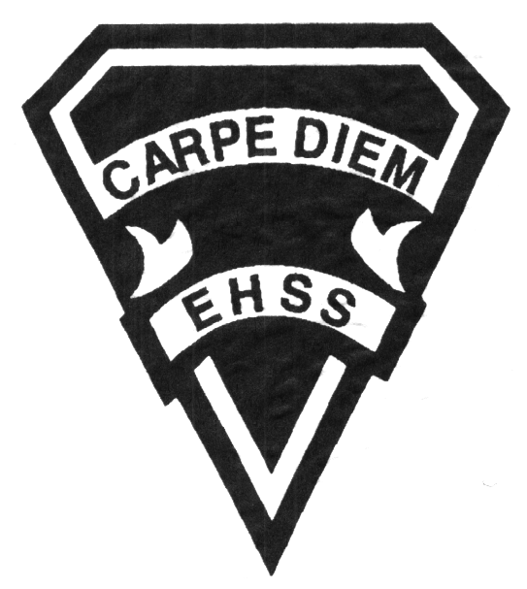

## Earl Haig

SecondarySchool

### ATB 20P

##### Grade 10 Ballet Major

**Dance**

# **Course Code**

**Evaluation Profile & Outline**

**Course Description/Rationale/Overview:** This course emphasizes the development of technical proficiency within the class and choreographic settings. Students will enhance their ballet training with increasingly difficult skills; become conversant with learning ballet choreography and repertoire; study historical and cultural aspects of dance, integrate injury prevention; learn and incorporate stage-craft; create and present complex compositions; and analyze and evaluate dance performances.

**Class Requirements:**

* ***Dress Code***:

Girls will wear pink tights, pink ballet slippers, black leotard, hair up, no bra straps or tummies showing.

Boys will wear a dance belt, ballet slippers, black tights, white or black leotard or tank top.

* The replacement cost for a lost costume is $75 - $125.

**Assessment and Evaluation Strategies**

Diagnostic, formative, summative

**Assessment:**

Homework checks, quizzes, peer assessment, presentations, reflection writing, observation.

**Evaluation:**

Video Exams,tests, assignments, performance, oral presentations, journals.

**Late and/or Missed Evaluation**

Our policy on late assignments and missed tests is in complete agreement with the school-wide policy. Late assignments must be accompanied with a note signed by a parent or guardian stating the reason for tardiness of the assignment. The note must list the due date of the assignment and the actual date of submission. If an assignment is handed in after it has been taken up/handed back, the student may not receive a mark for it.

**Subject-Specific/Department Information**

Attendance to all classes is mandatory. Failure to attend results in missed opportunities for studio work and a lack of teacher clarification and feedback. If a student is absent, they must bring a parent/guardian note and be responsible for all missed work. It is not the teacher’s responsibility to notify the student of missed work. The student must take an active role in the course material.

Dance Night & Dance Collective Night: Any student who has missed ***ten*** classes from September will not be allowed to participate in our annual performances. For special circumstances, an appeal may be written and submitted.

**Learning Skills\***

**Responsibility** – meets deadlines; takes responsibility for own behaviour

**Organization** – establishes priorities and manages time; uses information, technology and resources top complete tasks time management

**Independent Work** – follows instruction with minimal supervision; uses class time appropriately to complete tasks

**Collaboration** – accepts an equitable share of work in a group; builds healthy peer relationships; works with others to achieve group goals

**Initiative** – looks for opportunities for learning; demonstrates curiosity; approaches new tasks with a positive attitude

**Self-regulation** – sets own goals and monitors own progress; seeks assistance with needed; makes an effort with responding to challenges

###### Final Mark

**Year’s Work 70%**

Studio work, presentations, unit tests, technique, choreography written work, journals

**Final Summative Evaluation 30%**

Video Exams

**Achievement Categories and Weighting**

* **Knowledge / Understanding** 30 **%**: knowledge of facts and terms; understanding of concepts, principles, guidelines and strategies; understanding of relationships among concepts.
* **Application** 35**%**: studio work, technique, video exam, learning choreography.
* **Thinking Inquiry** 15**%:** Formulating questions; planning, selecting strategies and resources; analyzing and interpreting information, and forming conclusions.
* **Communication** 20**%**:Communication of information and ideas, communication for different audiences, use of various forms of communication.

*From: Ontario Ministry of Education. *Growing Success: Assessment, Evaluation, and Reporting in Ontario Schools*. Toronto: Ministry of Education, 2010, 11.



## Earl Haig

SecondarySchool

### ATB 20P

##### Grade 10 Ballet Major

**Dance**

# **Course Code**

**Evaluation Profile & Outline**

**Course Outline/Curriculum Strands:**

# **Creating, Presenting and Performing**

**A1. The Creative Process:** use the creative process, the elements of dance, and a variety of sources to develop movement vocabulary;

**A2. Choreography and Composition:** combine the elements of dance in a variety of ways in composing individual and ensemble dance creations;

**A3. Dance Techniques:** demonstrate an understanding of the dance techniques and movement vocabularies of a variety of dance forms from around the world;

**A4. Performance:** apply dance presentation skills in a variety of contexts and performances.

# **Reflecting, Responding and Analysing**

**B1. The Critical Analysis Process:** use the critical analysis process to reflect on and evaluate their own and others’ dance works and activities;

**B2. Dance and Society:** demonstrate an understanding of how societies present and past use or have used dance, and how creating and viewing dance can benefit individuals, groups and communities;

**B3. Connections Beyond the Classroom:** demonstrate an understanding of the purpose and possibilities of continuing engagement in dance arts.

# **Foundations**

**C1. Physiology and Terminology:** demonstrate and understanding of, and use correct terminology when referring to, the physiology of movement as it relates to dance;

**C2. Contexts and Influences:** demonstrate an understanding of the social, cultural and historical origins and development of dance forms, including their influence on each other and on society;

**C3. Responsible Practices:** demonstrate an understanding of safe, ethical and responsible personal and interpersonal practices in dance activities.

**Course Outline:**

* Course Introduction
* History of ballet project
* Ballet Technique classes throughout the year
* Floor Barre and Stretch Classes throughout the year
* Composition
* Nutrition & Health and Safety
* Injury Prevention
* Open House choreography, rehearsals, performances
* Dance Night choreography, rehearsals, performances